Military Order of the Purple Heart, Chapter 170
offering free clothing to vets in need,
Published: Friday October 29, 2010, and posted: November 2, 2010.

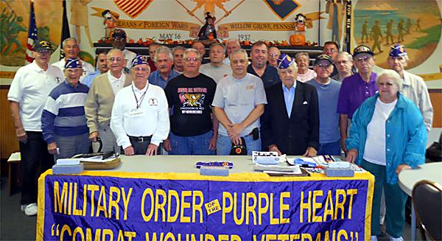

In recent weeks, Bob Lord of Doylestown has been seen at numerous department stores throughout the area — but probably not for the reason you’d expect.
The 63-year-old retired insurance executive isn’t a shopaholic, nor is he getting a jump on this year’s Christmas list. Rather, he’s going store-to-store acquiring some $10,000 worth of goods. The new items — from shirts and sweaters to T-shirts and wind-breakers for kids and grownups — will be distributed for free to needy veterans and their families in the region.
It’s a project of the Military Order of the Purple Heart, Chapter 170, based in Willow Grove, of which Lord is a member. The MOPH is the organization chartered by Congress for combat-wounded veterans, not to be confused with the group that collects used items.
“There’s a need not only because of the economy, but because many vets find themselves in difficult circumstances through no fault of their own,” said Lord, a decorated Vietnam vet. “This is a way to give back to them.”
Lord is buying the new goods, at a store discount, with money raised by Chapter 170 and its 280 members from throughout the Delaware Valley, all veterans of World War II through current conflicts. They will distribute the merchandise to needy vets and their families in the Philadelphia region on four dates in November and December at the Central Bucks Senior Center, 700 Shady Retreat Road, Doylestown. Times are Nov. 15, noon to 4 p.m.; Nov. 29, 2 to 6 p.m.; Dec. 6, 1 to 5 p.m., and Dec. 13, 1 to 5 p.m.
The first-time effort is one of several in which MOPH Chapter 170 is involved year round. Its top priority, it says, is to help any veteran in need with counseling services and money. The all-volunteer organization also assists “Comfort House” in West Philadelphia, a “home away from home” for out-of-town vets visiting Philadelphia for medical attention.
Other efforts include work with the Southeastern Veterans Center; Delaware Valley Nursing Home; Widows of Fallen Police Officers; Coatesville VA Hospital and the Multi Vet Center. The latter offers help with education, food and clothing. In addition, Chapter 170 has helped Bucks County Veterans Affairs purchase a van for vet transportation.
For additional information on the give-away, call Chapter 170 at 215-489-8609 or 215-822-7151.
SEMPER FI
PATRIOT BRUCE BOICE
VETERANS ADVOCATE
MILITARY ORDER OF THE PURPLE HEART
PA. SR. VICE COMMANDER
PA. FIRST RESPONDER CHAIRMAN
CHAPTER #170 CHAPLIN
1008 MEARNS ROAD WARMINSTER PA 18974
HOME AND FAX 215-674-4593 CELL 215-833-6031

